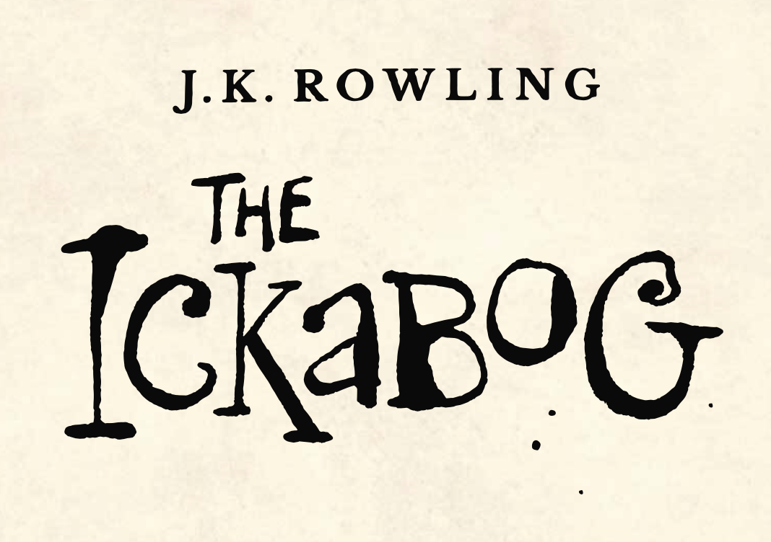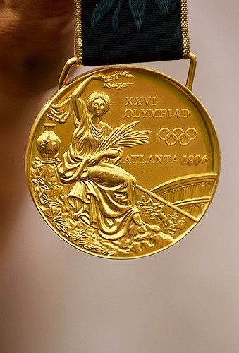

***"From an inner pocket, Spittleworth pulled out a most gorgeous gold medal, almost as large as a saucer. Embossed upon the medal was a monster with gleaming ruby eyes, which was being fought by a handsome, muscular man wearing a crown. The whole thing was suspended from a scarlet velvet ribbon."***

This description, from Chapter 20, should make it easy for you to draw the medal that will be presented to the families of Beamish and Button. Have a go at drawing the most gorgeous gold medal you can.

Now have a go at writing a description for this medal. Can you make your description so clear that someone else in your home could draw it without looking at it.