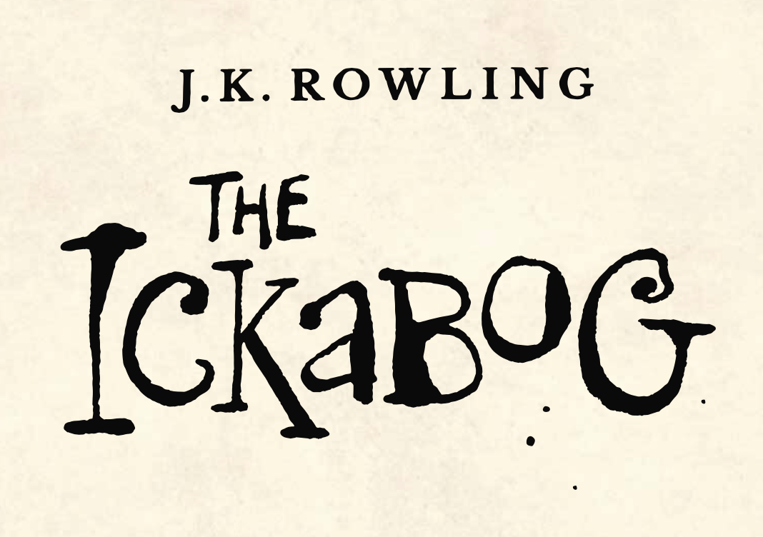

In Chapter 6 we are transported into the palace gardens where there is a bit of trouble brewing. Spittleworth and Flapoon do not like children and have lots of rules that children must obey, including being quiet, not jumping in the fountain or climbing the statues. Imagine you are Spittlework and Flapoon and create a poster with a very strict set of rules for the garden!