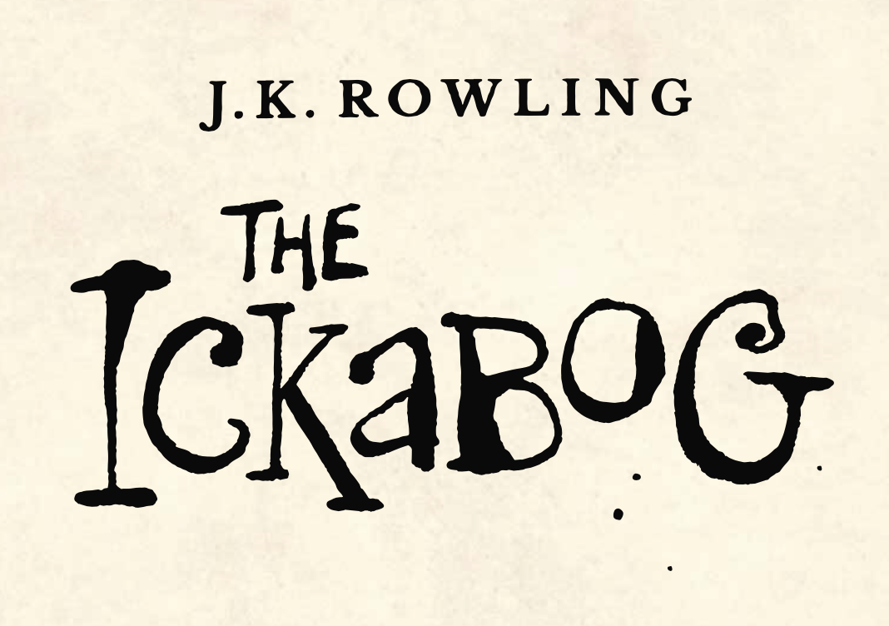

'We get Orphanage Cakes. Do you know what those are, my lord?’

‘No,’ said Spittleworth, against his will. There was something about this girl… What was it?

‘They’re made of spoiled ingredients,’ said Daisy, her dark eyes boring into his. ‘Bad eggs, mouldy flour, scraps of things that have been in the cupboard too long… People haven’t got any other food to spare for us, so they mix up the things they don’t want and leave them on the front steps. Sometimes the Orphanage Cakes make the children sick, but they eat them anyway, because they’re so hungry.’"

What is the worst recipe you can think of for an Orphanage Cake? Daisy says they have bad eggs, mouldy flour and things that are out of date.

Create your own recipe for an orphanage cake and write the instructions for the chef. Remember, each instruction should start with a verb such as...

Crack

Mix

Add

Pour

Stir

Share your recipe and drawing of your cake on the blog.