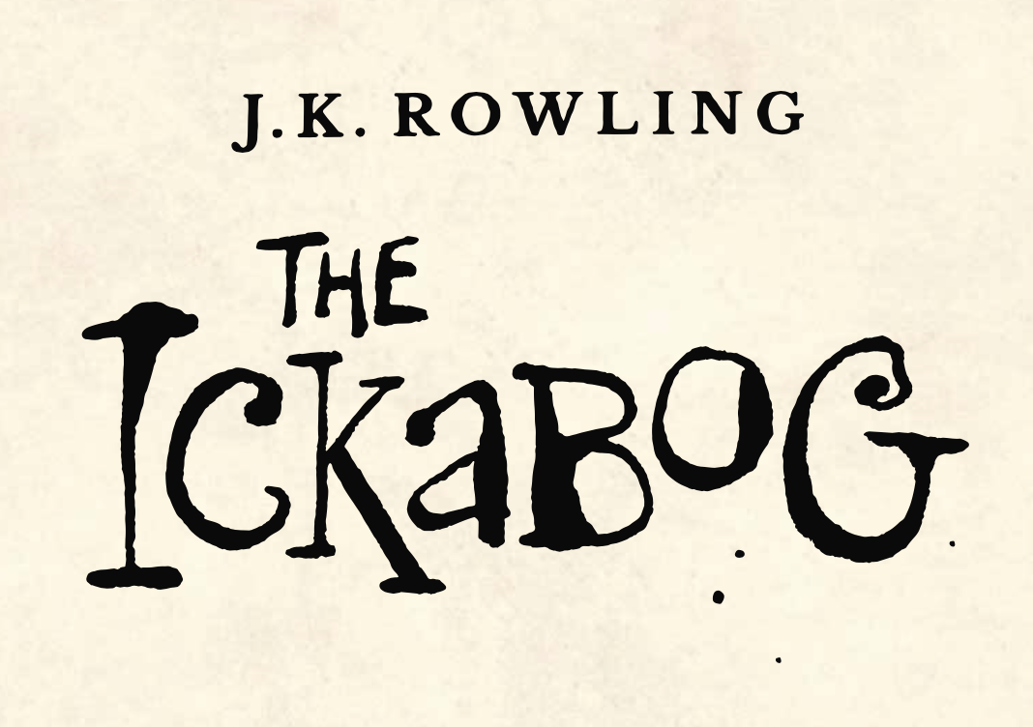

In Lord Spittleworth is hoping that the news of the Ickabog spreads quickly and makes the beast sound as fearsome as possible.

***"His entire plan rested on a king who not only believed in an Ickabog, but who was scared it might leave the marsh to chase him.”***

Your job is to help Lord Spittleworth with the most outrageous description of the Ickabog you can manage. In your description use words to describe its size, how it made you feel, the smell and the sounds.

Imagine you are telling everyone in Jeraboam all about this beast. Make it sound as scary as you can!