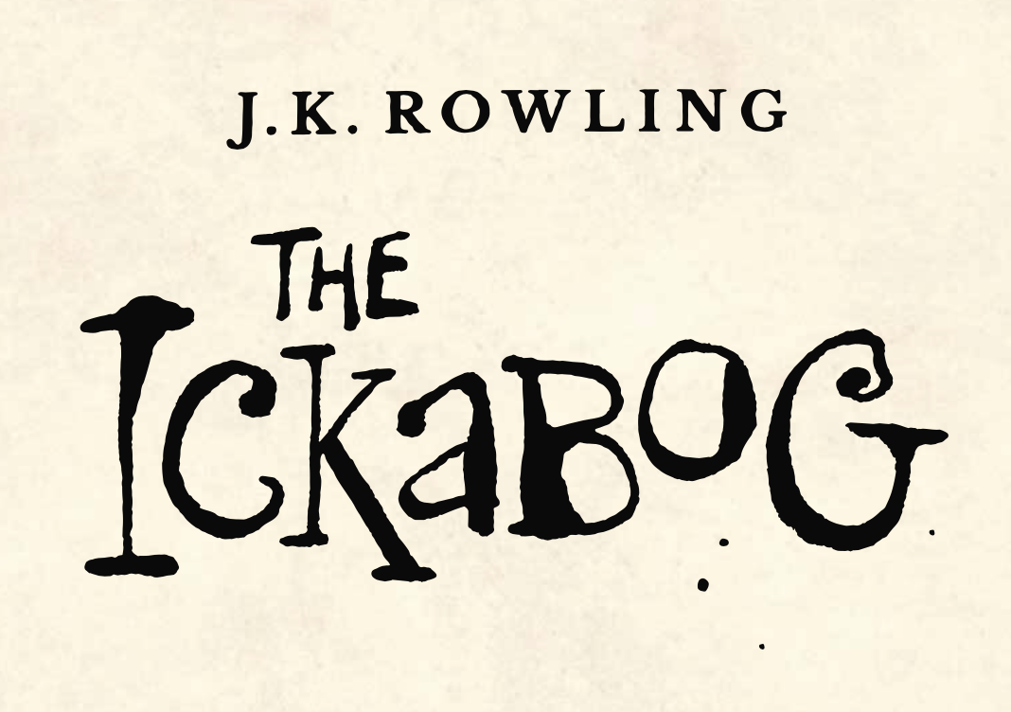

***"Not until he sneaked into Kurdsburg on the third night did he come face-to-face for the first time with a picture of himself on a Wanted poster, taped up in a cheesemongerâ€™s window. Luckily, the drawing of a neat, smiling young man looked nothing like the reflection of the grubby tramp he saw staring out of the dark glass beside it."***

What do you think Bert looks like when he is neat and tidy? What do you think he looks like now

Use the template (or a piece of paper) to draw both Berts. They are like two different people, but some things will always be the same such as the colour of his eyes, the shape of his nose and the smile on his face - if he is smiling at all!