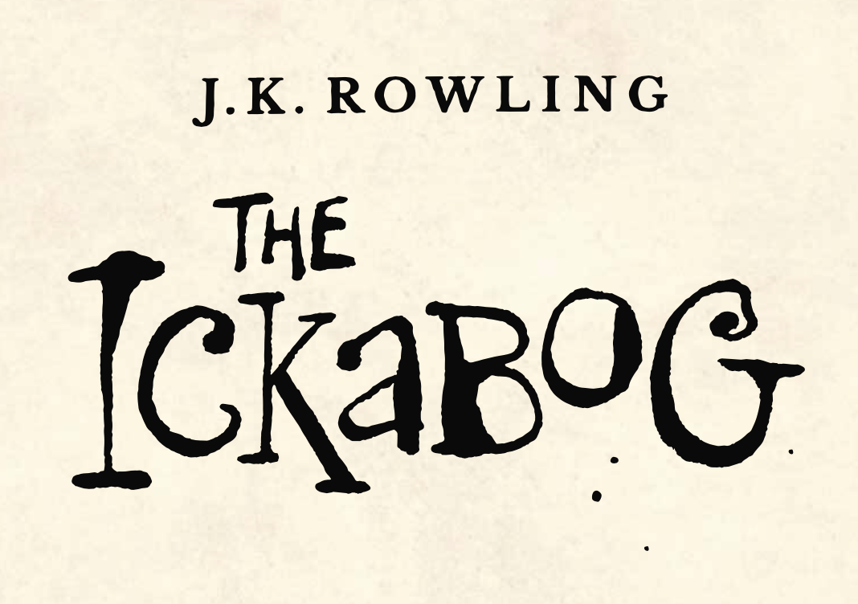

In Chapter One we meet King Fred. Use the description in the text to draw two portraits of King Fred. One should show his face in detail and one should show his fine clothes.

“King Fred the Fearless came to the throne on a huge wave of popularity. He had lovely yellow curls, fine sweeping moustaches and looked magnificent in the tight breeches, velvet doublets, and ruffled shirts that rich men wore at the time. Fred was said to be generous, smiled and waved whenever anyone caught sight of him and looked awfully handsome in the portraits that were distributed throughout the kingdom, to be hung in town halls. The people of Cornucopia were most happy with their new king, and many thought he’d end up being even better at the job than his father, Richard the Righteous, whose teeth (though nobody had liked to mention it at the time) were rather crooked.”