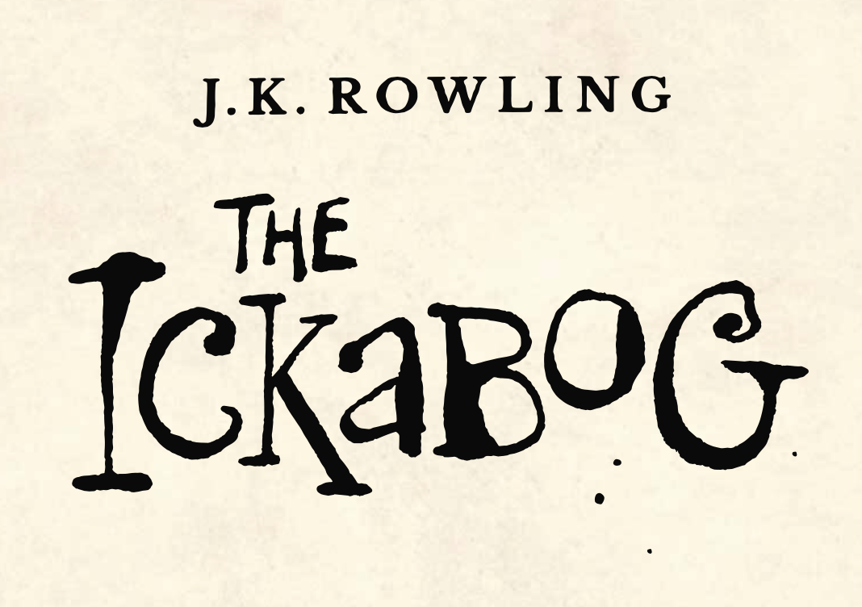

**WOULD YOU RATHER**

Always have to tell the truth

Always have to lie

**WOULD YOU RATHER**

Never be able to speak again

Have to say everything on your mind

**WOULD YOU RATHER**

Have hiccups for the rest of your life

Always feel like you are about to sneeze but can’t

**WOULD YOU RATHER**

Be sticky for the rest of your life

Be itchy for the rest of your life

**WOULD YOU RATHER**

Use sandpaper as toilet paper

Use hot sauce as a face wash

**WOULD YOU RATHER**

Have £1,000,000 now

Have £5,000 every week for the rest of your life

In Chapter Seven, Major Beamish faces a difficult decision.

So, can you make difficult decisions?

It’s time to play, would you rather!