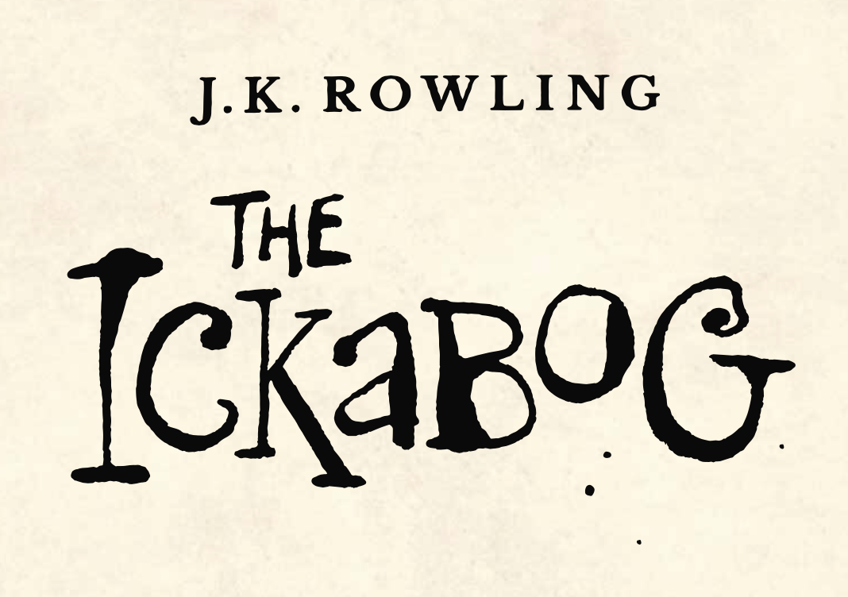

In Chapter Three we hear about the poor seamstress who died with one button left in her hand still to sew on to the outfit of the King.

Design your own glamorous outfit for the visit of the King of Pluritania.