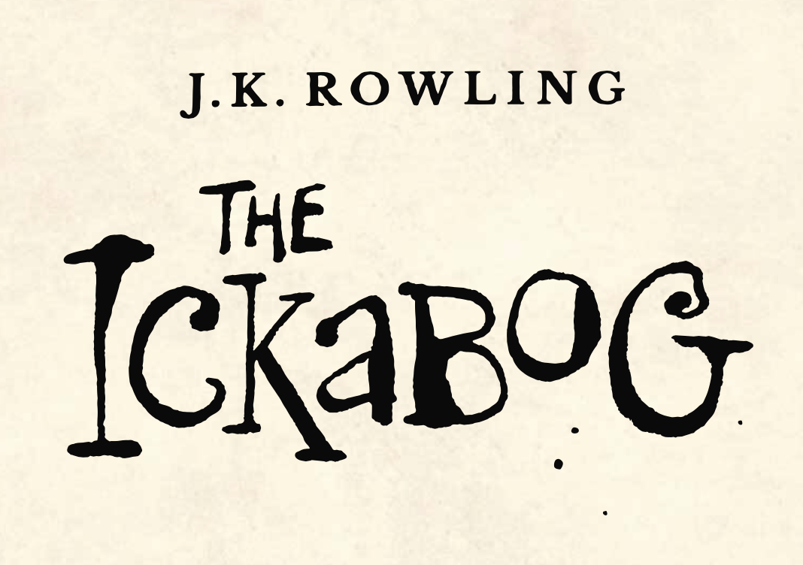

In Chapter 15 the King returns to Chouxville.

The chapter is packed full of people feeling different emotions. How did you feel reading this chapter? Were you scared? Were you sad? Were you worried for any of the characters?

Think about the six characters below.

In the chapter how do you think they are feeling?

Come up with three words that show their emotions during this chapter. You can use these words in your writing later in the book.

Fred the Fearless

Lord Spittleworth

Daisy Dovetail

Mrs Beamish

Bert Beamish

The People in the City