**First Name Adjective One word object**

**A** Arthur Big Chair

**B** Billy Little Head

**C** Connor Smelly Dog

**D**

**E**

**F**

**G**

**H**

**I**

**J**

**K**

**L**

**M**

**N**

**O**

**P**

**Q**

**R**

**S  
  
T  
  
U  
  
V  
  
W  
  
X  
  
Y  
  
Z**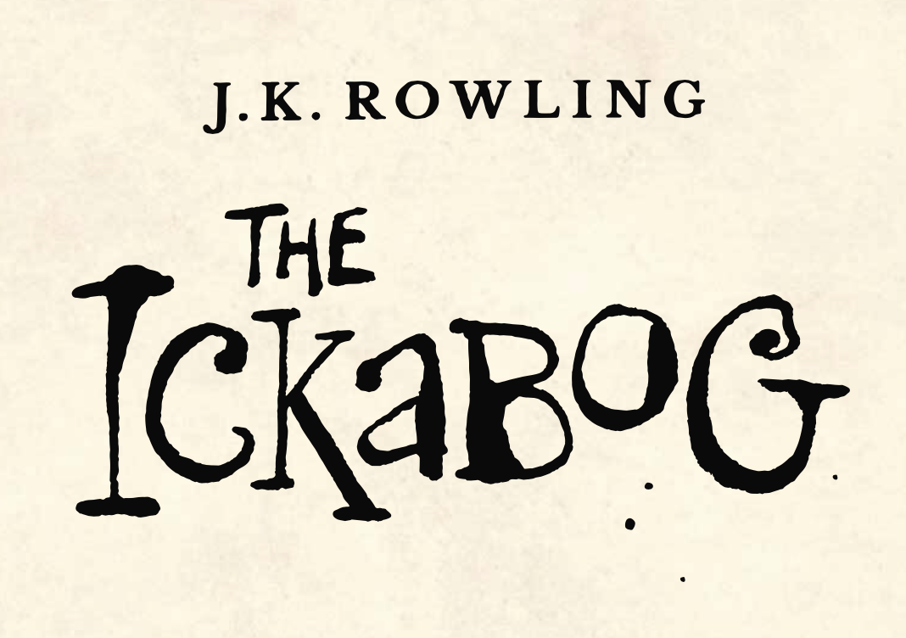

In Chapter 16 Lord Spittleworth comes up with the name Nobby Buttons because he looks around and sees Roach’s shining button. Your job is to create your own ‘Character Name Machine’.

Fill in the first names using the letters of the alphabet. Come up with 26 adjectives. Then, look around the room and find 26 objects.

The machine works like this. You get your first name by choosing the first letter of your surname and looking down the list, the first letter of your real first name gives you the adjective and the last letter of your first name gives you your object. So, Brenda Cane would become Connor Littlechair.